.
MUSIC STREAMING APP
INTRODUCTION:
Project Name: Music Streaming App
Goal: To design and develop a modern music streaming application that allows users to explore, play, and organize their favorite songs easily.
Role: UX/UI Designer and Developer
Tools Used: Figma, Adobe XD.
PROBLEM STATEMENT:
Many users face challenges finding a seamless and personalized music experience.
Existing platforms can be cluttered, slow, or lack tailored recommendations.
This project aims to create a clean, intuitive, and user-friendly app that provides smooth playback, smart suggestions, and easy playlist management.
Target audience/personas:
The app targets music enthusiasts of all age groups who listen to songs regularly through smartphones or desktops.
Their main needs include:
- Easy navigation and song discovery
- Personalized playlists based on mood or genre
- Offline music playback and minimal ads
Pain Points:
- Too many ads interrupting the experience
- Difficult navigation in existing apps
USER RESEARCH:
Research Methods: Online surveys, user interviews, and competitive analysis of apps like Spotify, Apple Music, and YouTube Music.
Key Insights:
- 75% of users prefer minimalistic UI and fast streaming.
- Personalized recommendations significantly increase engagement.
- Offline playback is one of the most requested features.
Findings:
A user-friendly interface with smart recommendations and flexible controls enhances the overall listening experience.
USERFLOW/JOURNEY:
1. User opens the app and logs in.
2. Browses the Home screen for recommendations or uses the Search option.
3. Selects a song or playlist to play.
4. Adds songs to a personal playlist or marks as favorite.
5. Adjusts playback controls and views lyrics.
6. Logs out or continues listening in background mode.
WIREFRAMES:
The low-fidelity wireframes show initial layouts for the Home, Search, and Player pages.
These sketches focused on basic structure, spacing, and content arrangement before adding colors or graphics.

UI DESIGN:
Splash screen with Spotify logo
Login / Signup page
Home screen with:
Recently played
Top mixes
New releases
Search screen with search bar and genre grid
Library screen with tabs for playlists, artists, albums
Now playing screen with:
Album art
Song name & artist
Play controls
Progress bar
Playlist details screen with songs list
Bottom navigation bar: Home, Search, Library
Dark theme with Spotify green accents
Circular fonts and rounded cards
Mini-player at bottom for quick access

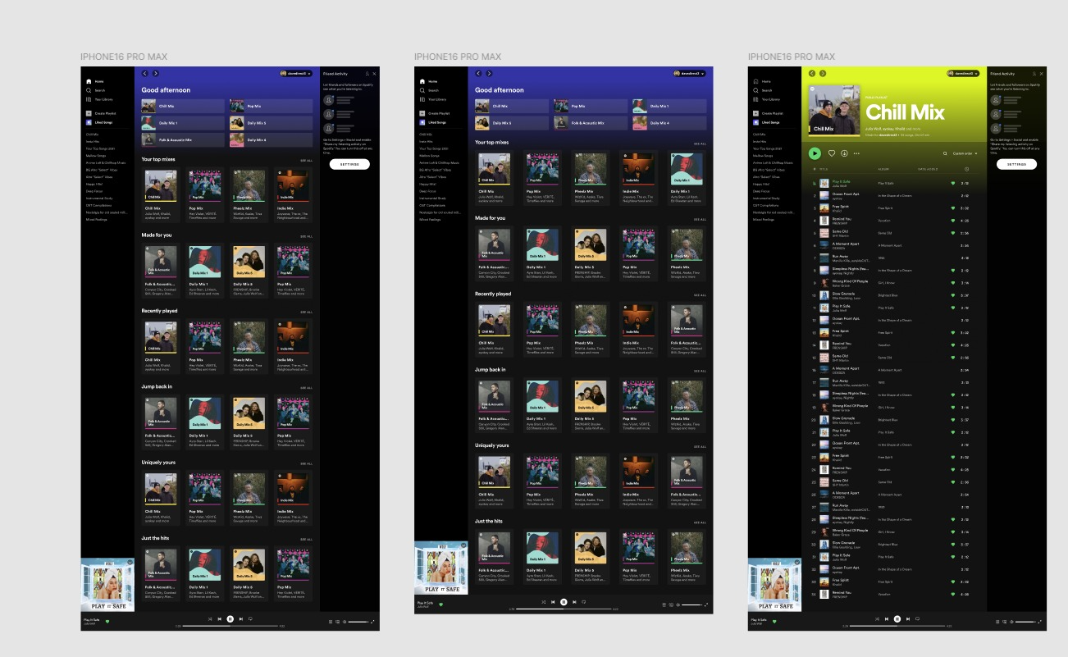
PROTOTYPE& INTERACTION:
Interactive prototypes were created in Figma to simulate app navigation and playback transitions.
Micro-interactions such as play/pause animations, swipe gestures, and loading transitions enhance the overall user experience.
CONCLUSION:
The Music Streaming App successfully delivers a personalized and user-centered approach to enjoying music anytime, anywhere.
It combines simplicity, speed, and smart features to improve user satisfaction and engagement.

